Casey Bement Portfolio Website

Purpose

The purpose of this website is to house my developer portfolio. I have been wanting to create my own website for my own projects and have a space to update with new projects. I will make this website available online so that future employers and recruiters are able to easily find out what I can do. It will show who I am, what I have done, what I can do, what I am working on, and what my passions are.

Target Audience

The target audience is mostly potential employers. That said, this will be a very professional looking site, using professional grammar and professional vocabulary. The audience may be as wide as possible so that anyone who wants to understand what I am doing, can do so quickly. However, I do not want the webpage to lack personality. The webpage will contain up to date information about myself and my projects.

Content

The content will overall feature information about myself and what I can and have done as a software developer. This can include a homepage with a quick professional bio, a blog containing what I am currently doing with my time, an about me page that will have a more in-depth description of who I am, a portfolio tab to show off specific projects, a resume page that can be easily updated and downloaded, and lastly and interests page to show some personality.

Similar Websites

Many developers have personal websites. The website itself can be an example of a developer’s front-end skills. That said, there are many personal portfolio websites, many can be very bland, and many can be very unique. I aim to accommodate as many demographics as possible, while still keeping a unique page. The pages I linked here was one of the first that came up over a simple google search, but it still contains the same basic information.
https://www.kaiwa-projects.com/
https://brittanychiang.com/

Site Map

The portfolio website will use a very straightforward hierarchy organization. The first main page is the home page, this will contain my contact information from the start. From there you can easily navigate to the other pages. This webpage is about efficient use of space, design, and information handling. More content pages can be added simply within each section.
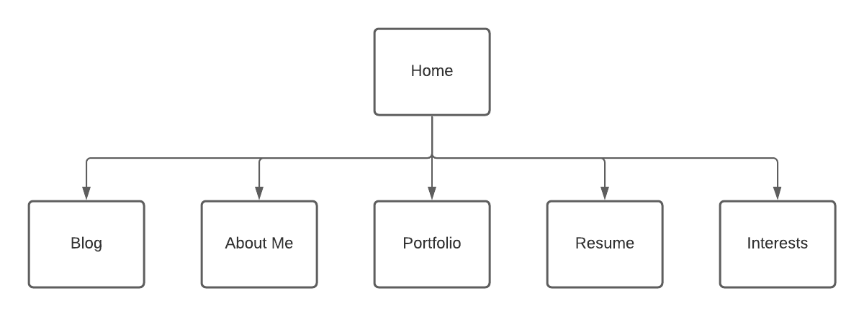
contact

Website Wireframe
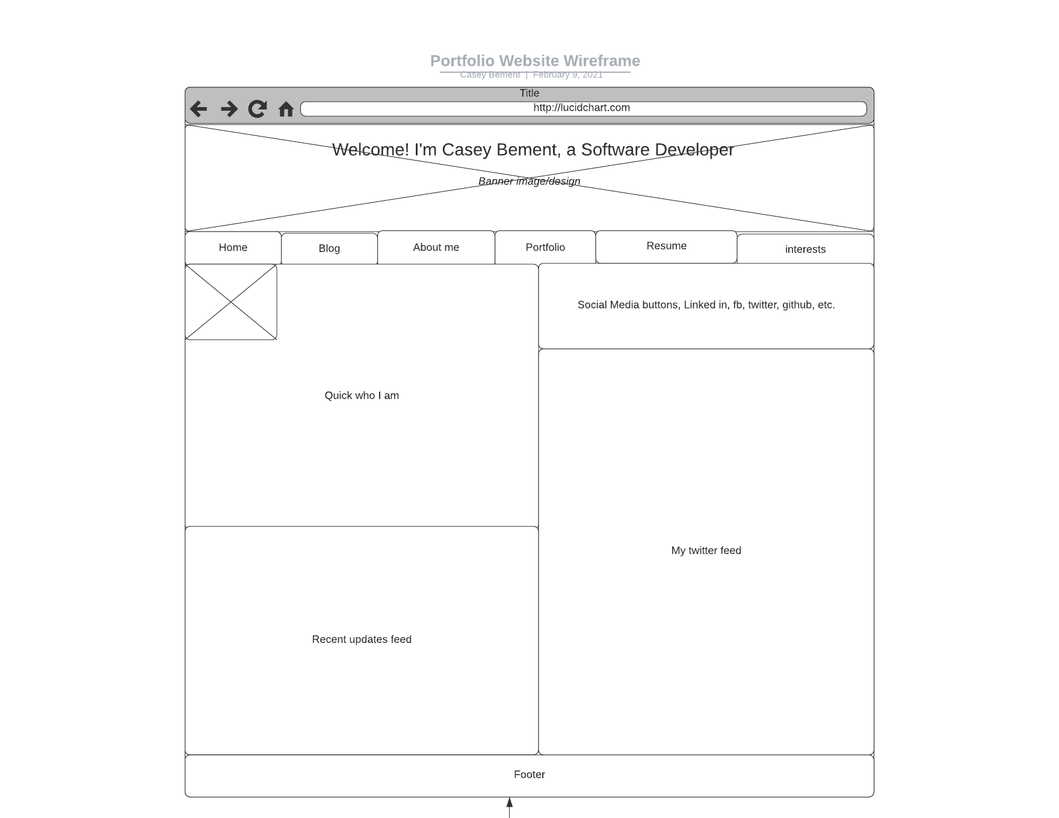
Color Scheme

The color scheme I have chosen is based on an outer space theme. It symbolizes an infinite possibility, and with that I think that it can convey the pursuit of knowledge. I prefer to browse the web in dark mode whenever possible, and it has become the trend. It offers less side effects and dark mode preference continues to grow. Thus, I will plan to offer a dark mode/light mode option. I used https://color.adobe.com/create/color-wheel to create this, the link does not preserve my choices. I am showing a light and dark mode portrayal. Here are the hex codes: #CC55E, #DFE4ED, #010329, #87322F. Paletton would not let me enter my own choice of color or let me adjust it as I see fit.
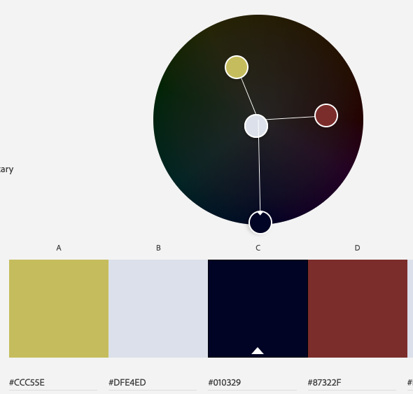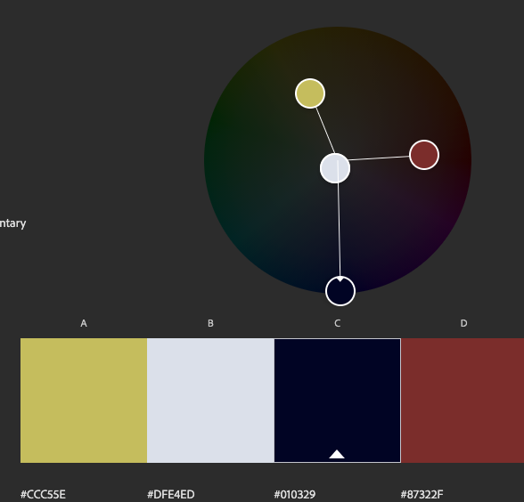

Font

My choice is Friz Quadrata, Arial and Arial Narrow. Friz Quadrata will be used for some larger headings, as it is quite interesting to look at. Arial can be used for some of the less important headings, and arial narrow is to be used for the bulk of information. Both of the Arial fonts have been chosen for enhanced readability.

Accessibility

The web design is kept straightforward for a simple and efficient navigation. As a portfolio website, you have mere moments to capture your audience. I plan to include lower quality images as I see fit, and if I include videos, they will not auto-play. I will implement a dark-mode/light-mode switcher but plan to operate as a dark mode normally. Font sizing can be optimized to both desktop and mobile as a start but will add an additional mobile format in the future. Descriptions for images will be included for hearing impaired. Large enough buttons for motor impaired, easy to understand UI/Language for learning disabled.

